Cover Sheet

# Selected Topics CS-1 Projects_Fall2022

Dr/ wessam elbehaidy

Team ID : 44

Numerical Dataset is “Churn_Modulling”

Image Dataset is “UTK”



Faculty of Computers and Artificial Intelligence

Computer Science Department

2022/2023

***Team Members :***

|  |  |  |
| --- | --- | --- |
| ID | Name | Grade |
| 202000548 | عبد الله شعبان عبد الرازق سيد |  |
| 202000510 | عبد الرحمن حمدي عبد العاطي عبد الحميد |  |
| 202000441 | شهاب الدين مختار السعيج عبد الحميد |  |
| 202000479 | طه سعيد شعبان |  |
| 202000171 | آيات ايمن حافظ الشال |  |
| 202000542 | عبد الرحمن ياسر سمير محمد |  |

***1.NUMERICAL DATASET***

* 1. **Dataset Details**
* Our numerical Dataset is “Churn-modelling”
* The total number of samples in dataset is 10000.
* The number of samples used in training is 7000
* The number of samples used in validation and

testing is 3000.

* 1. ***Implementation Details***

1. ***Logistic regression***

**The final Accuracy of this model is :**

**In v1 = 81.35**

**In v2 = 98.05**

**we implement our LR model with next hyperparameter:**

**penalty= 'elasticnet'**

**l1_ratio=0.9**

**C = 1.0 C which is ‘regularizer’**

**fit_intercept = True**

**solver = 'saga' solver which is ‘optimizer’**

**random_state= 0**

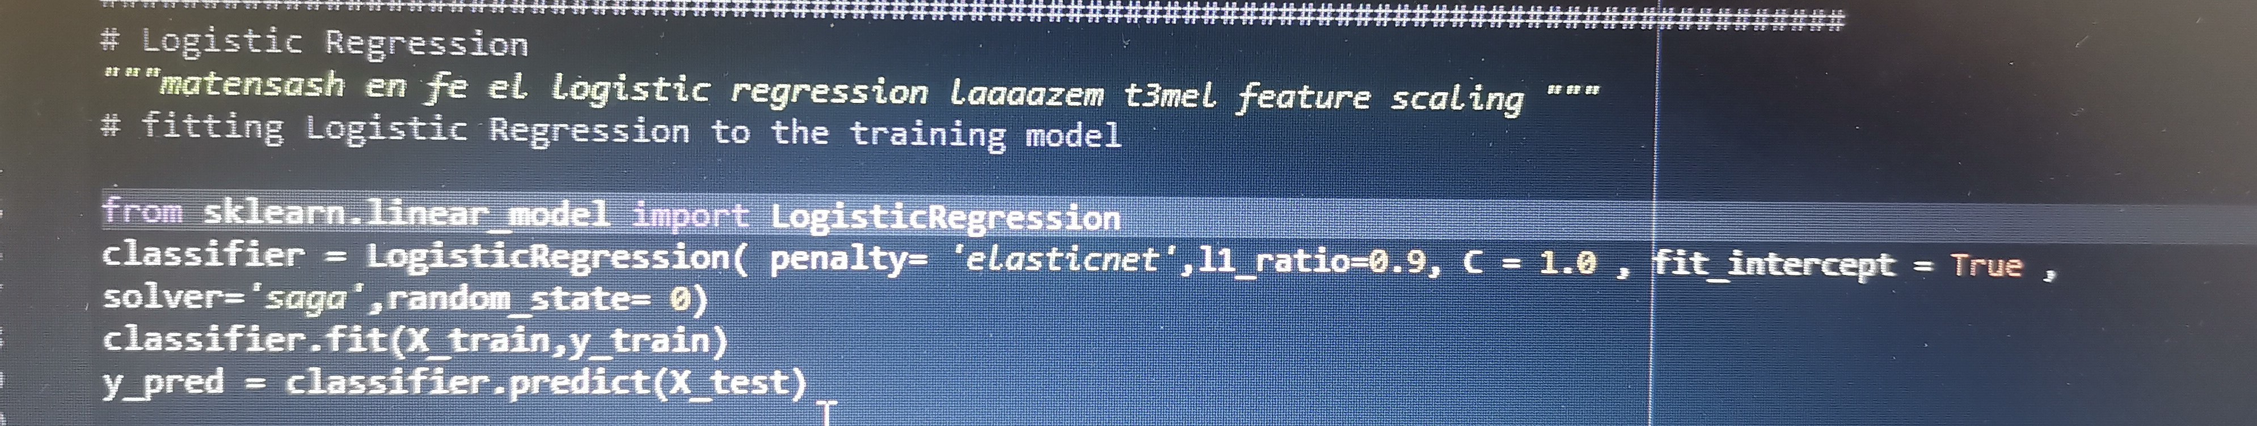

* **ROC of LR** 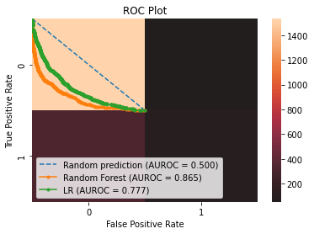

**Confusion Matrix of LR**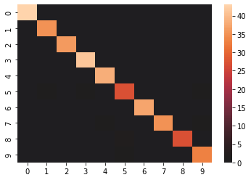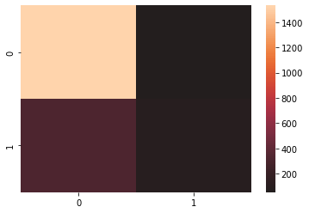

1. ***SVM***

**The final Accuracy of this model is :**

**In v1 = 86.4**

**In v2 = 98.2**

**we implement our SVM model with next hyperparameter :**

***kernel ='rbf'***

***shrinking = True***

***C = 1.0***

***degree = 3***

***coef0 = 0.001***

***gamma='scale'***

***probability = True***

***random_state = 0***

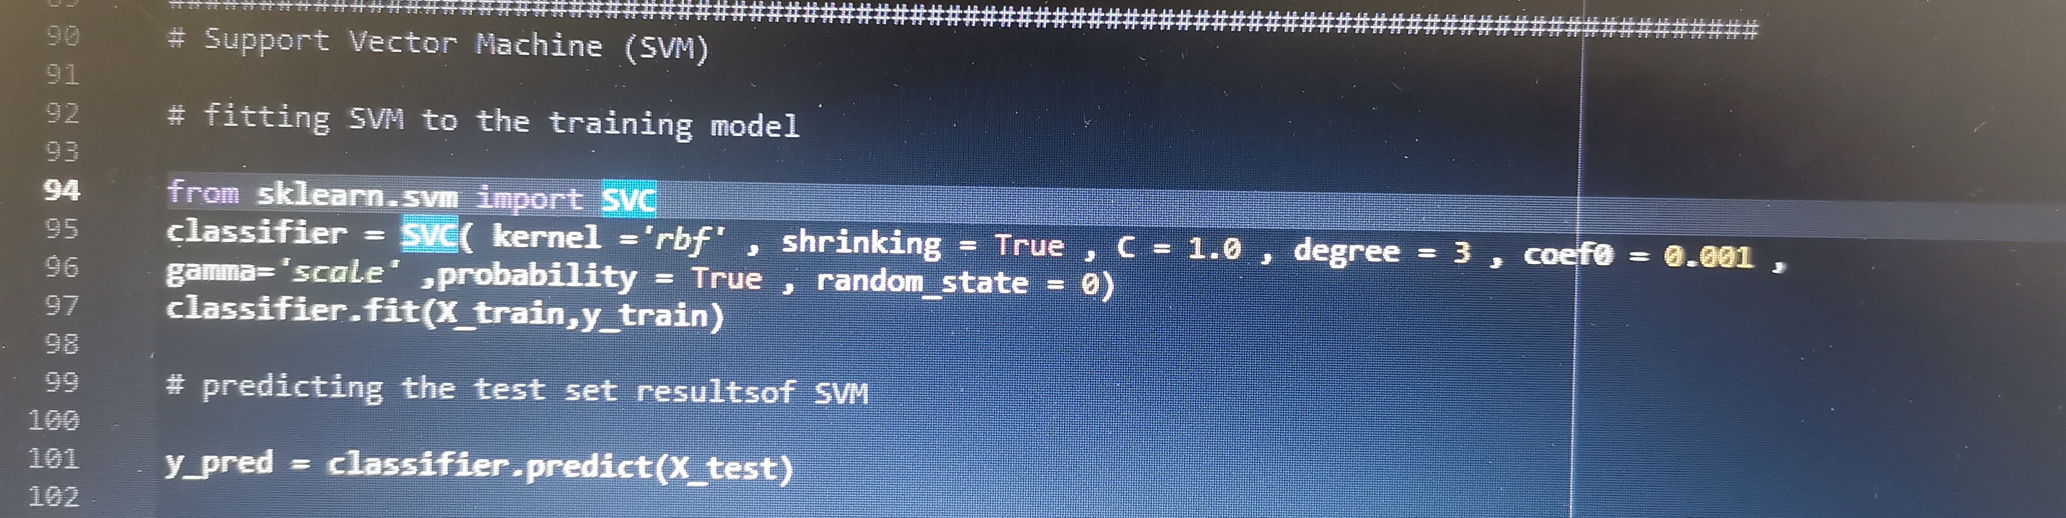

* ***Confusion matrix of SVM***

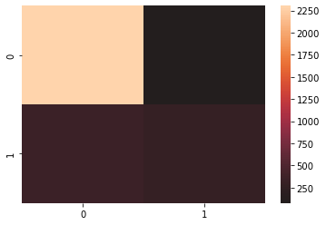

* ***ROC of SVM***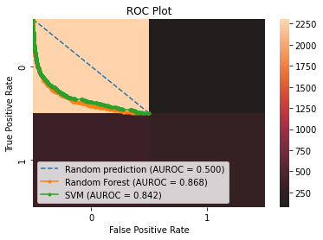

***2.Image Dataset***

**a.Dataset Details**

- Our Image Dataset is ‘UTK’

- The total number of samples in dataset is

10137

* The size is 852mb , 128 X 128
* The number of samples used in training is 7602 and
* the number of samples used in validation and testing is 2535

**b. Implementation Details**

***a.ANN model :***

- There are 2 feature extraction , their name : 1 - gray scale , 2- resize

- Hyperparameters used in the model is :-

Optimizer

batch size

epochs = 200

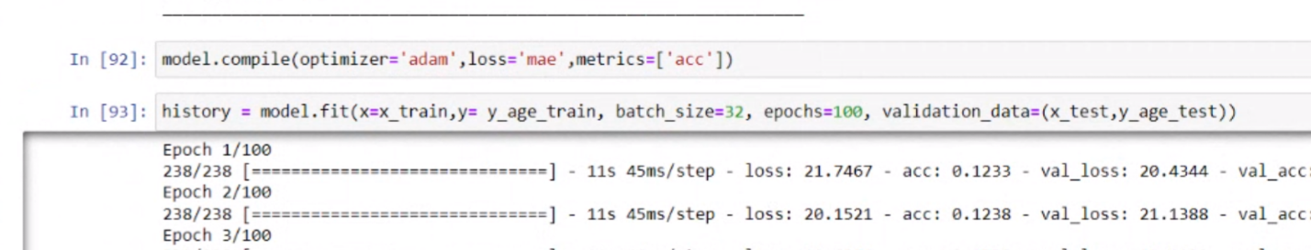

Result details :

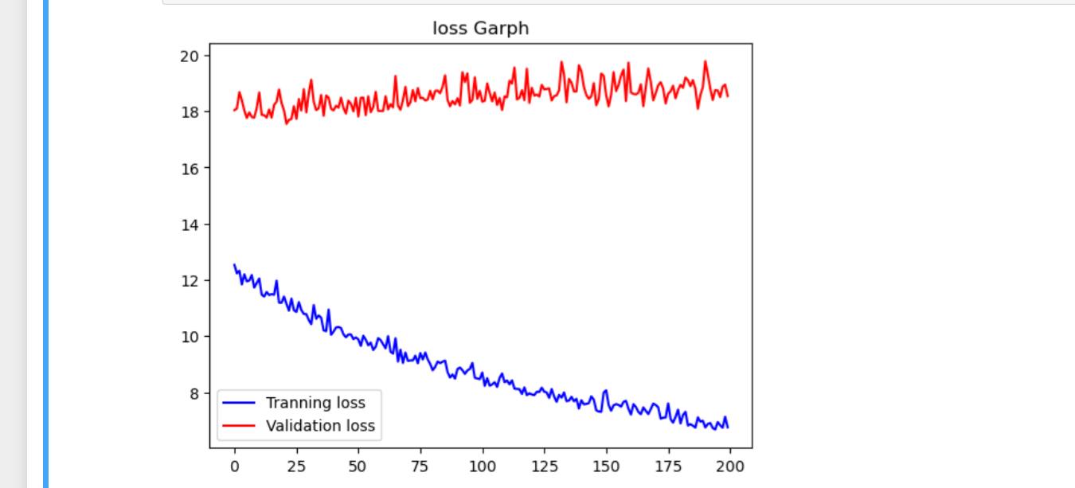

confusion matrix

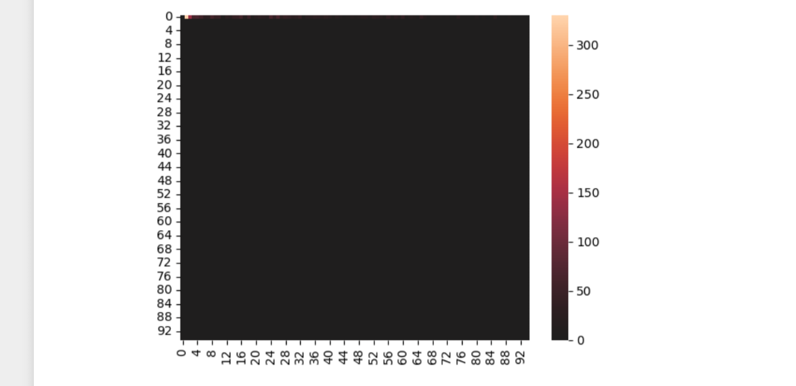

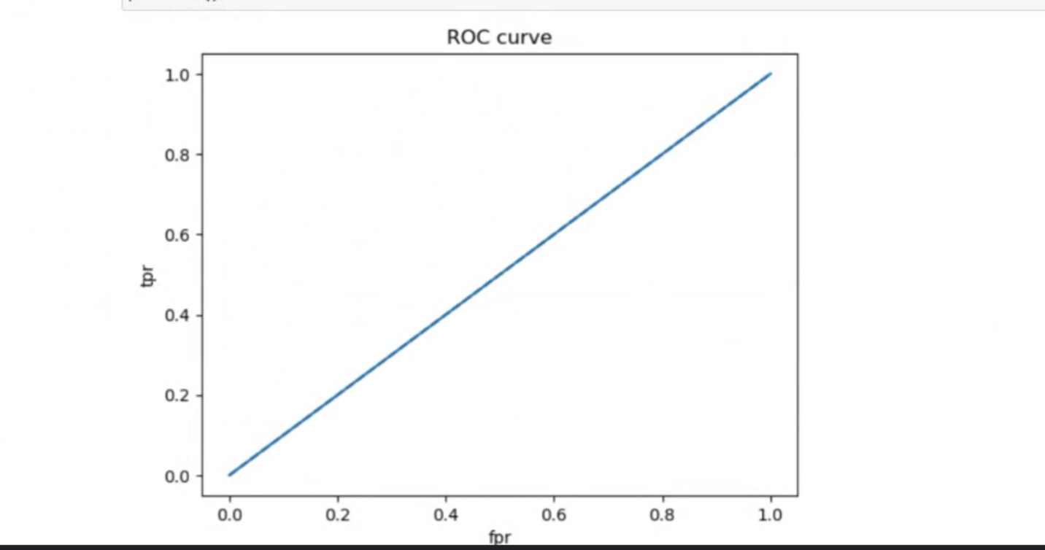

Accuracy = .12